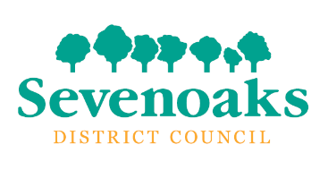
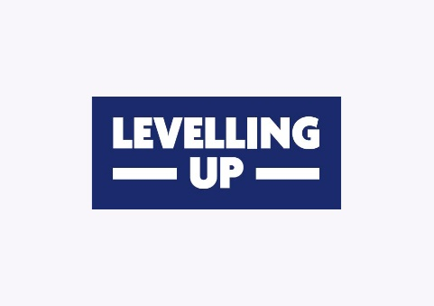

Guidance Notes and Application Form

2024/25

Cultural Sector Development

Working with local heritage and community organisations to help deliver greater access to cultural opportunities within the Sevenoaks District.

Culture plays an important role in bringing people together. The Cultural Sector Development Fund will help support community organisations, businesses, heritage institutions and new/existing arts groups to deliver community-led arts, cultural, heritage or creative programmes, for both residents and visitors to enjoy.

For example, this fund could help to support a programme that teaches new skills or craftmanship, offers cultural interactions or provides new opportunities for people to participate and experience our rich heritage of local history and traditions. Activities such as these could be delivered as a learned experience, group classes or staged performances.

If you would like to deliver a cultural sector development programme, this fund may be able to support you.

Criteria for funding

Please read the grant criteria below, as applications cannot be considered for funding unless they adhere to them.

- The fund is available for community-focussed arts and heritage activities within the Sevenoaks District, which benefit both residents and visitors to Sevenoaks and the surrounding areas.
- Applicants can apply for a maximum of £1,000 towards revenue projects.
- Organisations / projects can submit a maximum of one application in any financial year (April 2023 to March 2024)

- Applications can only be accepted on the fund’s application form. All questions should be completed, and all requested information provided.

- Partnership projects are encouraged, but the lead agency in terms of accountability must be made clear on the application.

What can the fund support?

Eligible projects supported by the fund must achieve all of the following:

- Provide demonstrable benefits for residents and visitors to Sevenoaks District and the surrounding areas

- Be able to provide evidence that the project has achieved its objectives.

Submission and next steps

Applications will be regularly reviewed and awarded whilst the limited funding remains available, so submission at the earliest opportunity is strongly encouraged.
To submit, please email this document fully completed to business.grants@sevenoaks.gov.uk.

How are applications assessed?

- Applications must demonstrate that they meet the criteria for funding.
- A panel from Sevenoaks District Council will review and decide on proposals. Sevenoaks District Council has discretion to include external representation on this panel but contact and financial information will not be shared.
- All applications will be appraised against the criteria set out in these guidelines and applicants will be notified as soon as possible.
- Grant payments will be issued in advance of the project commencing as soon as possible after the grant has been approved.

Conditions of funding

- Specific evaluation requirements will be set out in the grant offer letter.
- The grant must be used solely for the purpose outlined in the application.
- If not provided with your application, bank account details must be provided before any offer can be confirmed.
- Any unspent funds must be returned to Sevenoaks District Council.
- The project should be completed by 28 February 2025 and due to funding restrictions, extensions cannot be provided.
- Project publicity must recognise the grant from Sevenoaks District Council and the UK Shared Prosperity Fund (UKSPF) as per the brand guidelines.
- The project must complete, and an evaluation form must be returned to Sevenoaks District Council within four weeks of the completion of the project, including evidence of expenditure and feedback from beneficiaries.
- Sevenoaks District Council reserves the right to suspend a project and recover all or part of the grant in the following situations:
  - Non-compliance with the terms and conditions of the grant as set out in the Guidelines and grant conditions.
  - A fundamental change to the project (as submitted) has been made without the prior consent of Sevenoaks District Council.
  - The delivery organisation is no longer capable of delivering the project.

Sevenoaks District Council
Cultural Sector Development Fund
Application Form

- Name of your organisation (state the lead organisation if more than one organisation is involved and answer all subsequent questions in relation to the lead organisation)

- Type of organisation (please provide relevant registration numbers e.g. charity/company registration where applicable):

Registered Charity
Community Group
Social Enterprise
Volunteer Group
Charity Organisation
Commercial business
Other (please give details)

- Please confirm whether your organisation has the following:

Constitution | Yes/No
Bank Account (if yes, please write out the relevant details) | Yes/No
Equality Policy | Yes/No
Health and Safety Policy | Yes/No
Safeguarding policy that covers children and young people | Yes/No
Safeguarding policy that covers vulnerable adults
Do all staff and volunteers working directly with children, young people or vulnerable adults have Enhanced DBS checks? | Yes / No

Where you have answered yes, please provide copies of the relevant documents.

- Does your organisation have any quality marks or other awards? Please give details here.

- Your name and position in the organisation / group

- Your contact details

Address:

Phone:

Email:

Website:

Social Media:

- Briefly describe the project that the grant will fund. Include where the project will be delivered, who will benefit, how they will benefit and how you know there is a need for the project (maximum 300 words.)

Project start date:
Project end date:

- Please give more details about the people who will benefit from your project:

How many people in total will benefit?

Will your project focus on any particular demographic group(s)? Please specify
Where in the Sevenoaks District will your project be delivered?

9. Finances – please give a breakdown of how the grant would be spent.

Item / Activity | Amount £
Total amount requested (revenue)

If the total cost of your project is greater than the amount requested, please give details of where the other funding will come from and whether or not this has been received.

- Briefly explain how your project meets the eligibility criteria in the guidance above (maximum 200 words.)

11. How will the project involve local people in the running and development of the project or activity?

12. Equal opportunities - How will you ensure that your project is accessible to all residents who would benefit? Please include information about how you would publicise the project.

13. How are you going to measure success? You will be asked to identify the success of your project on the project feedback form, so it’s important to think about this now.

14. Your signature.
This must be the signature of the main contact identified above.

- I confirm that I am authorised to sign this application on behalf of the organisation named in question 1.
- I confirm that to the best of my knowledge the information in this application form is true and correct.
- If this application is successful, I agree to ensure that the funds are spent as described here.
- I agree to ensure that the organisation complies with all monitoring and other grant conditions.
- I agree to complete and return the final evaluation form.
- I confirm that my organisation will conform to all relevant statutory requirements.

Signed

Date

Please return your completed application form to Sevenoaks District Council’s Economic Development team at business.grants@sevenoaks.gov.uk

The Cultural Sector Development Fund is funded by the UK Government through the UK Shared Prosperity Fund.

